Python Programming Assignment: Mastering Array

Student Name: 24-01-2026
Date:

Project 1: The Inventory Manager (Lists)
Background: You are managing a stock list for a small tech store. You need to keep track of the items available in the shop. Task: 1. Create a list named inventory containing: "Laptop", "Mouse", and "Keyboard". 2. A new shipment of "Monitor" arrives; add it to the list. 3. The store sells the "Mouse"; remove it from the inventory. 4. To make the list easier to read, sort the items alphabetically. 5. Print the final inventory and the total number of items left.
Code:
BOLD = "\033[1m"
ITALIC = "\033[3m"
UNDERLINE = "\033[4m"
RESET = "\033[0m"
print(f"{BOLD}{UNDERLINE}{ITALIC}=== The Inventory Manager ==={RESET}")
Inventory=["laptop","mouse","keyboard"]
inp=int(input("If u want to see the original inventory press 1: "))
print()
m=0
if inp == 1:
print(f"{BOLD}{UNDERLINE}=== Original Inventory ==={RESET}")
for i in Inventory:
print(f"{m}) {i} ", end=" ")
m+=1
else:
print("enter a valid number.")
print()
print()
print("New Shipment arrived!! and is added to the list successfully 😊.")
Inventory.append("monitor")
print()
inp1=int(input("If u want to see the updated inventory press 2: "))
print()
c=0
if inp1 == 2:
print(f"{BOLD}{UNDERLINE}=== Updated Inventory ==={RESET}")
for i in Inventory:
print(f"{c}) {i} ", end=" ")
c+=1
else:
print("enter a valid number.")
print()
print()
inp3=int(input("Congrats! 🎉 a sale has taken place and mouse is sold! press 3 to see the updated Inventory."))
print()
Inventory.remove("mouse")
n=0
if inp3==3:
print(f"{BOLD}{UNDERLINE}=== Updated Inventory ==={RESET}")
for i in Inventory:
print(f"{n}) {i} ", end=" ")
n+=1
else:
print("enter a valid number.")
Inventory.sort()
print()
print()
inp4=int(input("To see a sorted Inventory press 4: "))
print()
x=0
if inp4==4:
print(f"{BOLD}{UNDERLINE}=== Updated Inventory ==={RESET}")
for i in Inventory:
print(f"{x}) {i} ", end=" ")
x+=1
else:
print("enter a valid number.")
print()
print()
inp5=int(input("To see a sorted Inventory press 5: "))
z=0
if inp5==5:
print(f"{BOLD}{UNDERLINE}=== Length of Inventory ==={RESET}")
print(f"Length of Inventory is: {len(Inventory)}")
print()
print(f"{BOLD}{UNDERLINE}=== Final Inventory ==={RESET}")
for i in Inventory:
print(f"{z}) {i} ", end=" ")
z+=1

Output:
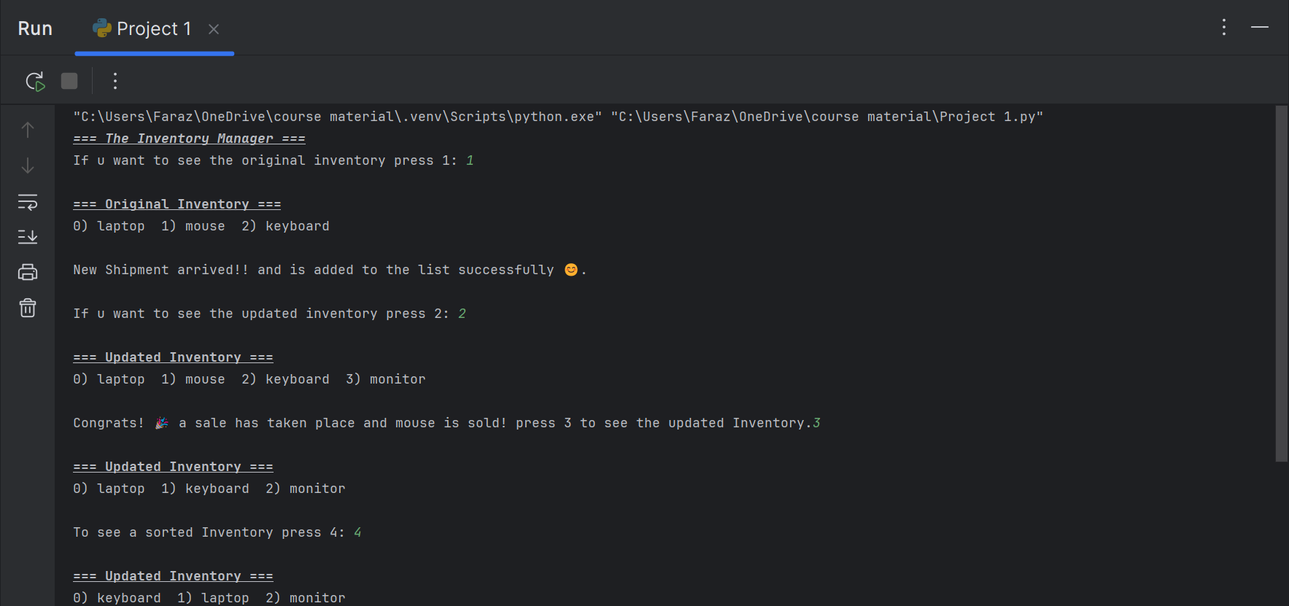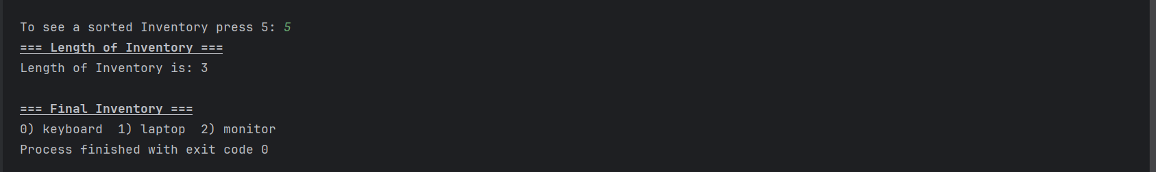

Project 2: The Immutable GPS Log (Tuples)
Background: A drone is recording its flight path. Once a coordinate is recorded, it must not be altered to ensure the flight log remains accurate for legal reasons. Task: 1. Create a list called flight_path containing three tuples. Each tuple should hold a (Latitude, Longitude) pair. 2. Access and print the Latitude of the second coordinate. 3. Attempt to change the Longitude of the first coordinate to 0.0. 4. Use a try-except block to catch the error and print a message explaining why the data cannot be changed.
Code:
flight_path = [(12.5, 55.6), (54.9, 60.0), (33.3, 40.6)]
# Task 1: Print latitude of 2nd coordinate
print(flight_path[1][0])
# Task 3: Attempt to change 1st tuple's longitude to 0.0 (will fail)
try:
flight_path[0][1] = 0.0 # Direct tuple change → TypeError
except TypeError:
print("Data cannot be changed because tuples are immutable to ensure flight log\n"
"accuracy for legal reasons.")
Output:
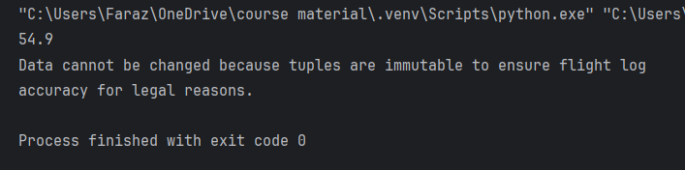

Project 3: The Event Guest Filter (Sets)
Background: You have two lists of guests: one for the "Opening Ceremony" and one for the "Gala Dinner". Some people are invited to both, and you need to avoid sending duplicate invitations. Task: 1. Create two sets: opening_ceremony and gala_dinner with at least two overlapping names. 2. Find and print the names of guests who are attending both events. 3. Create a master list of all unique guests who will be attending at least one event. 4. Identify guests who are attending the "Opening Ceremony" but are not invited to the "Gala Dinner".

Code:
# Task1: creating two sets
opening_ceremony={"Faraz","Ayan","Zaviar","Rohan"}
gala_dinner={"Faraz","suhaib","Zaviar","Jatin"}
# Task2: Find the names attending both events
print(f"Guests attending both events: {opening_ceremony & gala_dinner}")
# Task3: List of guests attending atleast one event
unique=opening_ceremony ^ gala_dinner
Final_lst=[unique]
print(f"Guests attending at least 1 event: {Final_lst}")
#Task4: Guests in opening ceremony but not in gala dinner
print(f"guests in opening ceremony but not in gala dinner: {opening_ceremony-gala_dinner}")

Output:
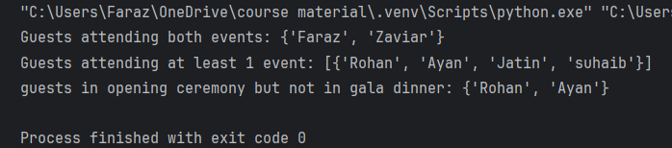

Project 4: The Employee Directory (Dictionaries)
Background: You are building a simple HR tool to look up employee extension numbers by their last names. Task: 1. Create a dictionary named directory where the Keys are employee names and the Values are their 4-digit extension numbers. 2. Add a new employee, "Smith", with extension 4002. 3. Use the .get() method to look up the extension for "Jones". If "Jones" is not in the directory, it should return "User Not Found". 4. Delete the entry for an employee who has left the company. 5. Print all employee names and their extensions in a clear format using a loop.
Code:
# Task1: create a dictionry named directory
directory = {"Faraz": "0007","Khurram":"1728"}
# Task2: Add another employee
directory["Smith"]="4002"
# Task3: use .get() method
if directory.get("Jones") not in directory:
print("User not Found.")
else:
print("User found.")
# Task4: delete an employee record
directory.pop("Khurram")
# Task5: print the final dictionary
for i,y in directory.items():
print(f"{i} => {y}")

Output:
